Муниципальное бюджетное общеобразовательное учреждение
средняя общеобразовательная школа №3Труновского муниципального района Ставропольского края

Урок по теме: «Вершины мира»
6 класс
(Автор учебника Ю.Е. Ваулина)
Учитель: Чалченко Е.М.

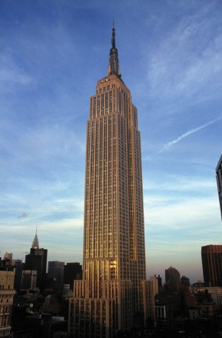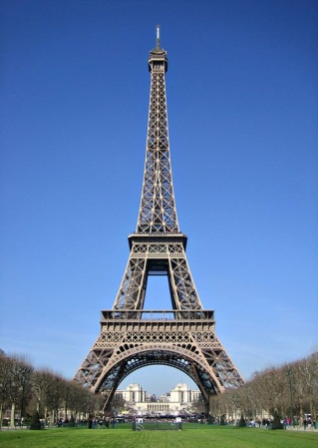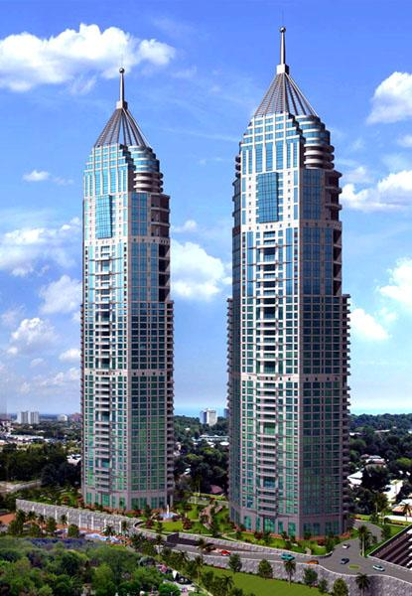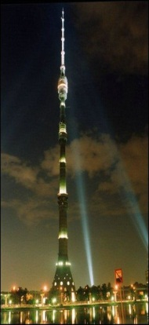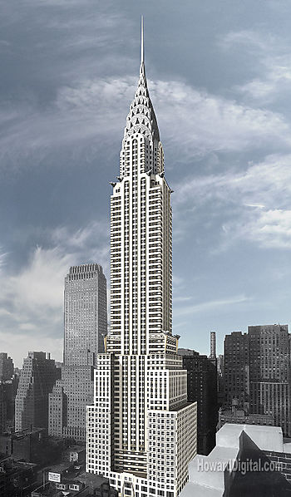

с. Безопасное 2013год
Тема урока: Вершины мира.
Цель урока: расширение страноведческих и лингвистических знаний учащихся.
Задачи урока:
Воспитательные: укрепление интереса к предмету, воспитание уважительного отношения к зарубежной культуре.
Развивающие: развитие умений прогнозирования содержания текста; развитие умений
поискового чтения.
Образовательные: изучение практики использования превосходной степени прилагатель-
ных, формирование умения делать сообщение в связи с прочитанным текстом. Оборудование: мультимедийный проектор для демонстрации слайдов в программе PowerPoint, CD-презентации, магнитофон, аудиозаписи.
Development (ход урока)
I The beginning of the lesson.
- Greeting.
Good morning, dear boys and girls. (T Cl )
Goodmorning, Good morning, Good morning to you,
Good morning, dear teacher,
We are glad to see you.
I’m glad to see you too. Sit down, please.

How are you, Kirill? - I’m fine, thak you. (T P1, P2, P3)
And what about you, Ulya? – I’m OK, thanks.
How is your brother, Maksim? - He is fine, thank you.
And how are you, E.M. I’m OK, thanks. (P1, P2, P3 T )
How is your family? They are fine, thanks.
T: Great. Let’s start our lesson.
- Doing the puzzle
T: Well, friends, to begin with, have a look at the screen, please. Here is a puzzle for you to do.
Name all the words in the pictures, take only the first letter of each word and you will read
the topic of our lesson.

 |  |  |  |  | 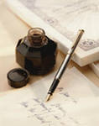 |  | 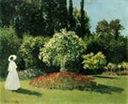

 | 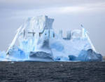 | 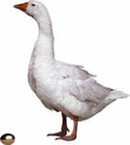

For example, a balloon – letter “B”

P1,P2,P3,P4 …..Balloon - “B”, uniform – “u”, ice cream – “i”, Lamp – “l”, dog – “d”, ink – “i”, nose – “n”, garden – “d”.
Ball – “B”, iceberg – “i”, goose – “g”.
T: So, what key word have we got? Right you are! Building Big
(слайд 1)
There are a lot of big buildings in the world. And today we are going to talk about them.
II Phonetic Drill.
Look at the screen and let’s read the names of these buildings.

The Chrystler Building (319 m) The Imperial Towers (254 m)
The Empire State Building (443 m) Burj Khalifa (828)
The Minerva Building (159 m) The Makkah Clock Royal Tower (587 m)
Big Ben (96,3 m) The Eiffel Tower (324)
The Petronas Towers (452 m) The Ostankino Tower (540 m)
(Слайд 2)
Now match the buildings to the countries
1. The Imperial Towers a) Malaysia
2. The Empire State Building b) India
3. Burj Khalifa c) The USA
4. The Makkah Clock Royal Tower d) The UK
5. Big Ben e) France
6. The Eiffel Tower f) Russia
7. The Petronas Tower g) The United Arab Emirates
8. The Ostankino Tower h) Taiwan
(слайд 3)
Keys : 1b; 2c; 3g; 4h; 5d; 6e; 7a; 8f.
(слайд 4)
III Speech Drill.
(повторение грамматического материала: степени сравнения прилагательных)
- Which building is taller Big Ben or the Ostankino Tower?
- Which building is the tallest?
- Is the Empire State Building taller than the Eiffel Tower?
- Where is the tallest building in the world?
- Which building is the lowest?
IV Listening.
Well, children , I want you to listen to the text about the Empire State Building.

The ESB is the tallest building in New York. It is 443 metres high and has 103 floors. It was built in 1930, and took one year and forty-five days to complete.
The ESB is one of the largest office spaces in the world, but it also has many shops and restaurants inside.
The ESB has 73 super fast lifts. The fastest of these travel from the ground to the 80th floor is only 45 seconds! If you choose to walk to the top, you need to climb 1860 steps.
At the ESB most visitors go straight to the Observatory on the 8 6th floor. The view is amazing. On a clear day you can see for miles around. Looking at the ESB from a distance is also great. The top floors are decorated with beautiful lights. These change colours every day. Depending on the occasion, the building can be white, green, blue, purple, red or orange!

If you are ever in New York, don’t forget to visit the ESB. It offers the best view of New York, and it is one of the city’s historic buildings.
Mark the statements (R) for Right, (W) for Wrong and (DS) for Doesn’t Say.
- The Empire State Building is the tallest building in America.
- Lots of people work inside the Empire State Building.
- You can get to the top of the Empire State Building in 45 seconds.
- The lights on the top floors of the Empire State Building change colours many times a day.
(слайд 5)
V Musical pause.
Well done. I see you are very tired. Let’s rest a bit and sing our favourite song.

If you are happy and you know, clap your hands.} Twice
If you are happy and you know and you really want to show,
If you are happy and you know, clap your hands.

If you are happy and you know, clap your fingers.} Twice
If you are happy and you know and you really want to show,
If you are happy and you know, clap your fingers.

If you are happy and you know, clap your legs.} Twice
If you are happy and you know and you really want to show,
If you are happy and you know, clap your legs.

If you are happy and you know, step your feet.} Twice
If you are happy and you know and you really want to show,
If you are happy and you know, step your feet.

If you are happy and you know, say OK.} Twice
If you are happy and you know, and you really want to show,
If you are happy and you know, say OK.

If you are happy and you know, do all fives.} Twice
If you are happy and you know, and you really want to show,
If you are happy and you know, do all fives.
VI Reading.
Well, children. It’s time for reading. Open your books. Page 81, exercise 3. Read the text and find five adjectives in the superlatives. What does each describe?
Now let’s watch a short video film about the Empire State Building.

VII Speaking. Work in groups.

I want you to tell us about some buildings.
The first group (the tallest building in the world)
The second group (the tallest building in our country)
The third group (one of the tallest building in our village)
(слайд 6)

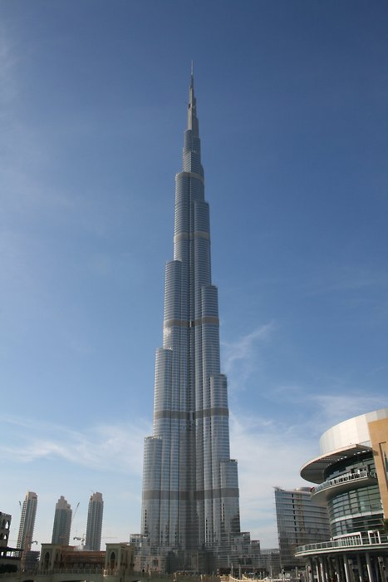 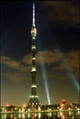 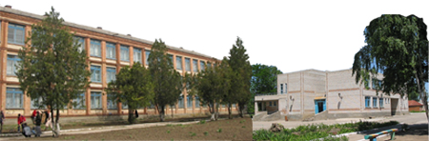 Name: The Burj Khalifa The Ostankino Tower Secondary School
City: Dubai Moscow Village Bezopasnoe
Height: 828m 540 about 15m
Number of floors: 163 45 3
When built: 2010 1967 1973
Type : Mixed-use Multifunction complex School building
What a visitor can do\ observation deck, enjoy an Get education, school activities,
see there: the world’s highest amazing view of the city go in for sports
observatory deck with an

VIII Writing.
( Рабочая тетрадь упр. 1 стр.50)

IX. The end of the lesson.
Reflection.

Our lesson is going to the end. And now I want you to show your attitude to our lesson. Did you like it? What new did you know? Your homework will be to make a story about the building you liked most of all.

Thank you very much for your active and hard work at the lesson. It’s very pleasant to work with you, and these are your marks for the lesson.

(Презентация)

